Michael Smith

CSE 460 – Operating Systems

Lab 3 (Worth 20 Points)

1.) Replacing a Process image

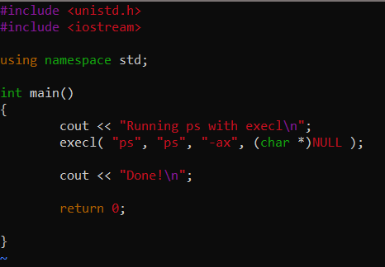

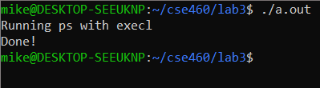

2.) Duplicating a process image

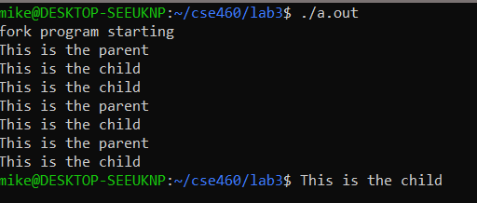

The parent process is create 3 times while the for loop is running and the child is outputted 5 times. The processes us a turn order system while outputting and share resources.

3.)Waiting for a Process

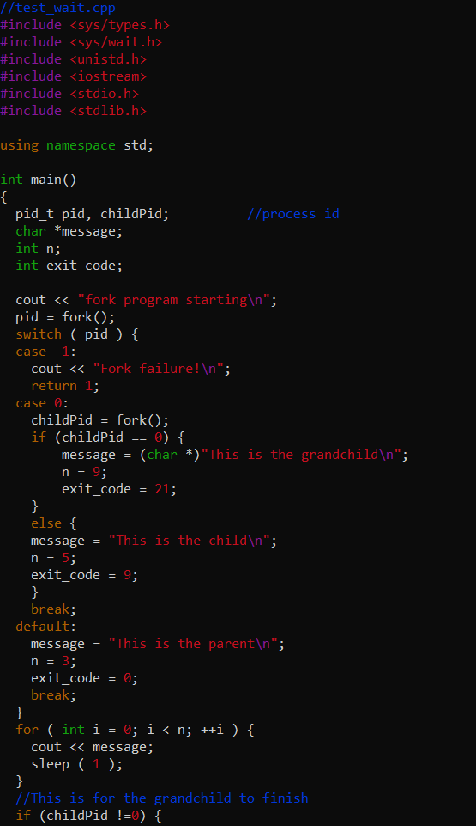

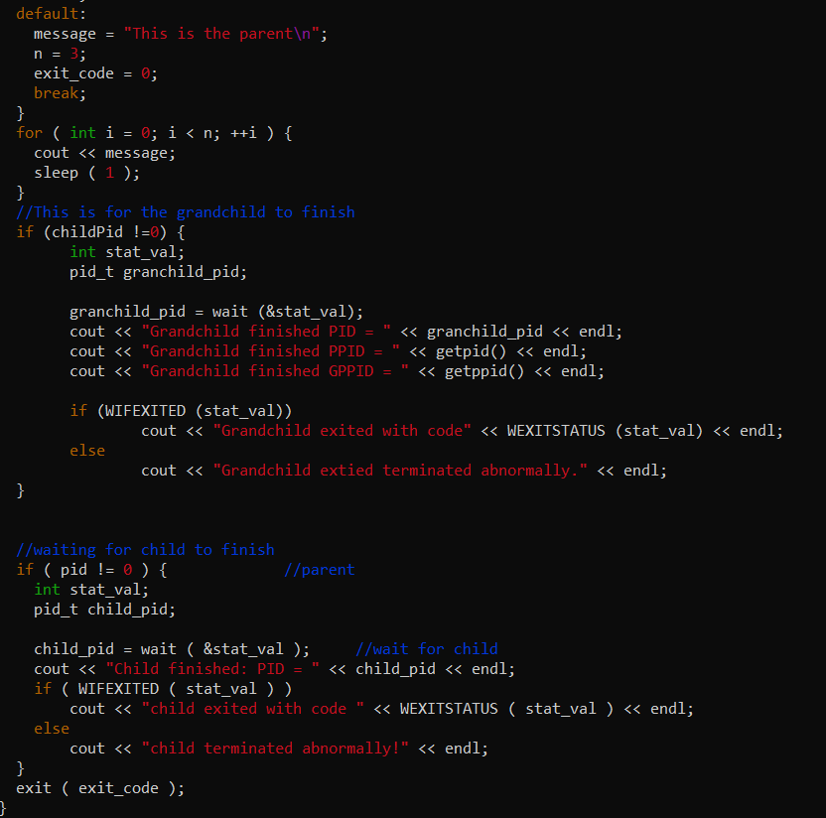

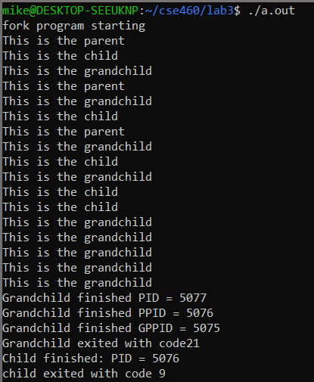

4.) Signals

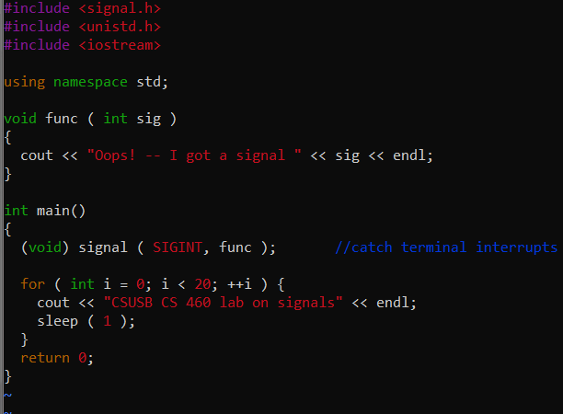

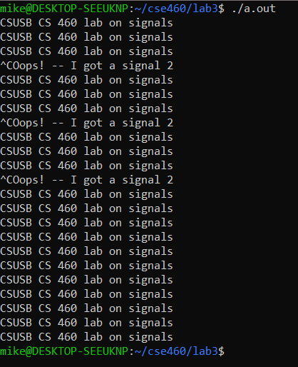

When pressing ^C, the output comes from the func(), while signal() catches the SIGNIT sent by the ^C. The SIGNIT value then becomes 2.

Test_alarm.cpp output only since the code was provided and unmodified.

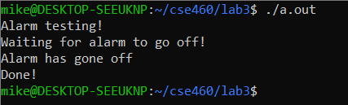

This program runs initially with the "Alarm testing! Waiting for alarm to go off!" Then after a few seconds the second two lines follow up. The parent process says the message then pauses while listening to the signal. Then the child process sleeps. Next it uses kill to send its signal back to the parents. Since the parents are listening, the alarm is sounded.

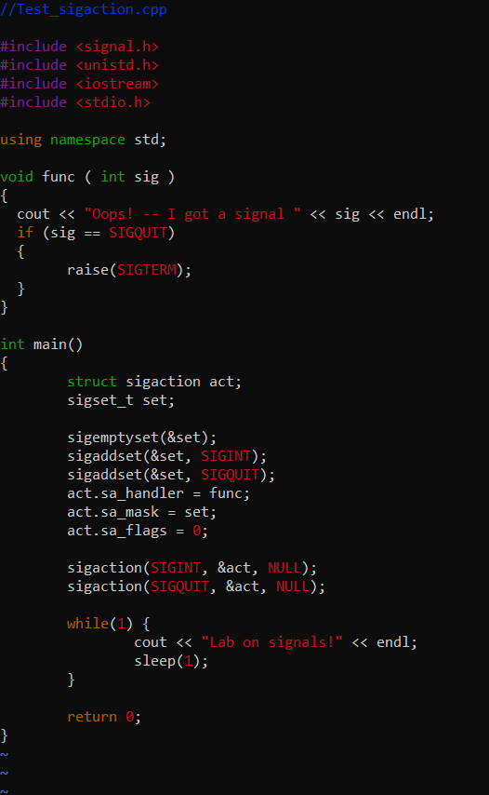

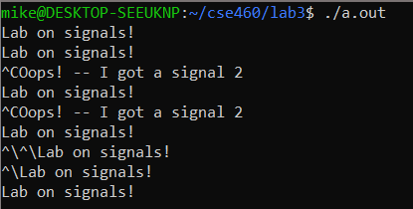

Unfortunately the Windows Subsystem does not support the ^\ command. So due to a bug in the subsystem with SIGQUIT, the code would continue to run.

5.) XV6

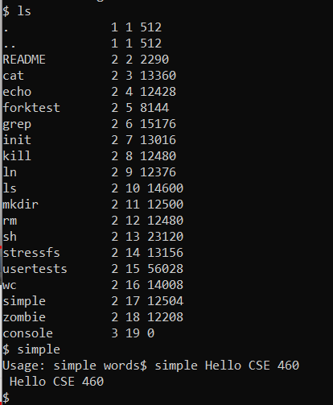

Conclusion: I was able to complete every question on the lab, all the code was functional. Even was able to create the simple file in the XV6 OS. Unfortunately due to a bug that was not in my control the ^\ command is not working. But that as I said is out of my control, so I don’t believe I should lose points for it.

Total: 20/20